* 1. Design a flowchart to take a number as input, store it in a variable, and print its cube.
* 2. Create a flowchart to convert the temperature in Fahrenheit to Celsius. The user should input the temperature in Fahrenheit, and the flowchart should display the corresponding temperature in Celsius. The formula to convert Celsius to Fahrenheit is C = (F - 32) × 5/9
* 3. Design a flowchart to take three integers a, b and h as input, where a and b are the length of the parallel sides of a trapezium, h is the distance between the parallel sides, and print the area of the trapezium
* 4. Create a flowchart to find the average of three numbers. The flowchart should take three inputs from the user and display their average
* 5. Design a flowchart to take an integer consisting of 4 digits as input and print the last 2 digits of that number.
* 6. Design a flowchart to take an integer consisting of 4 digits as input and print the first 2 digits of that number.
* 7. Design a flowchart to take three integers a, n, d as input where a is the first term of an arithmetic sequence, n is the number of terms and d is the common difference between the terms in the sequence and print the n-th term of the arithmetic sequence.
* 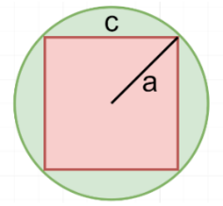8. Design a flowchart to take two numbers a and c as input (look at the image below) and print the area of the portion colored in green. In the following image, a is the radius of the circle, and c is the length of the sides of the square.

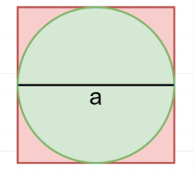

* 9. Design a flowchart to take a number as input (look at the image below), and print the area of the portion colored in red. In the following image, a is the diameter of the circle.